**Acid bases Practice worksheet**

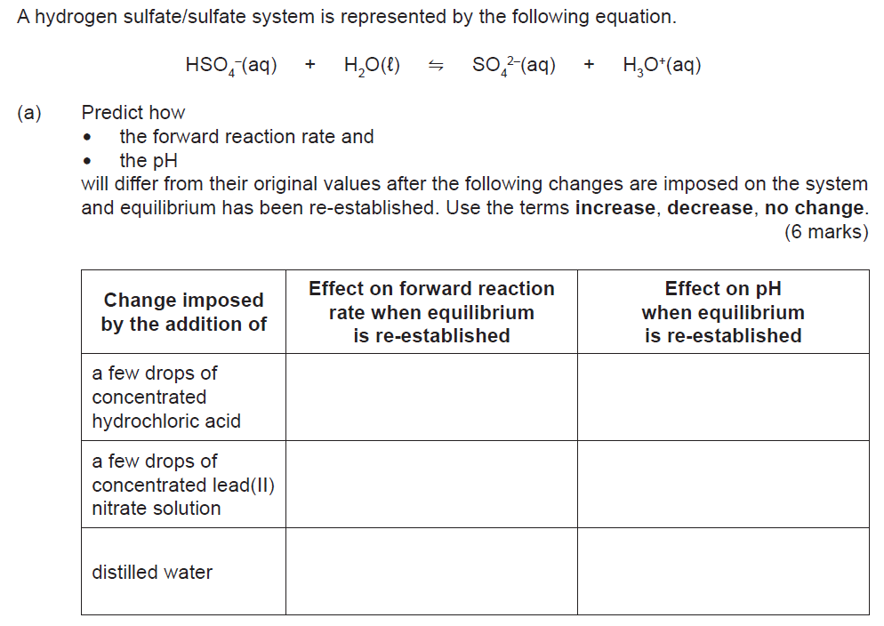

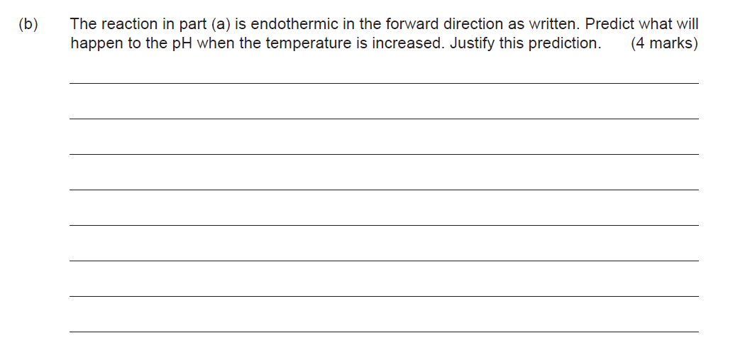

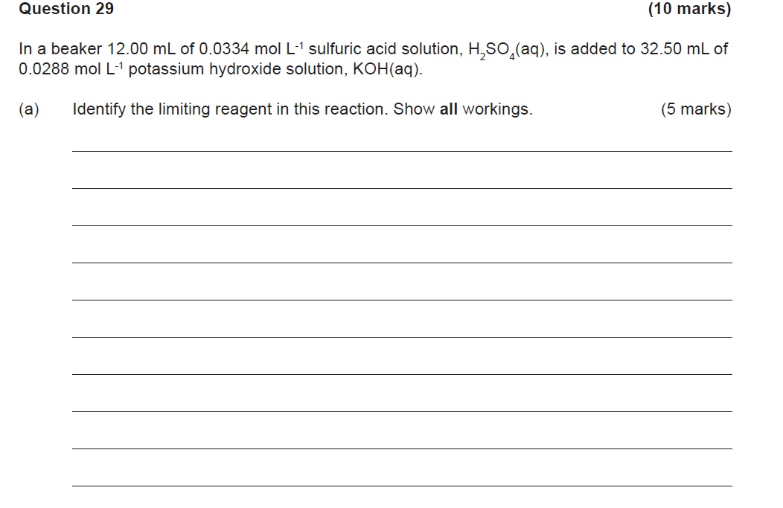

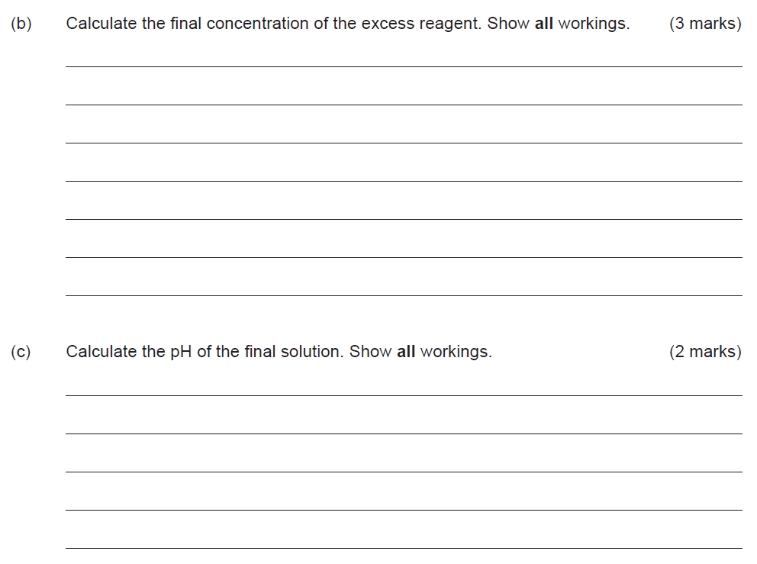

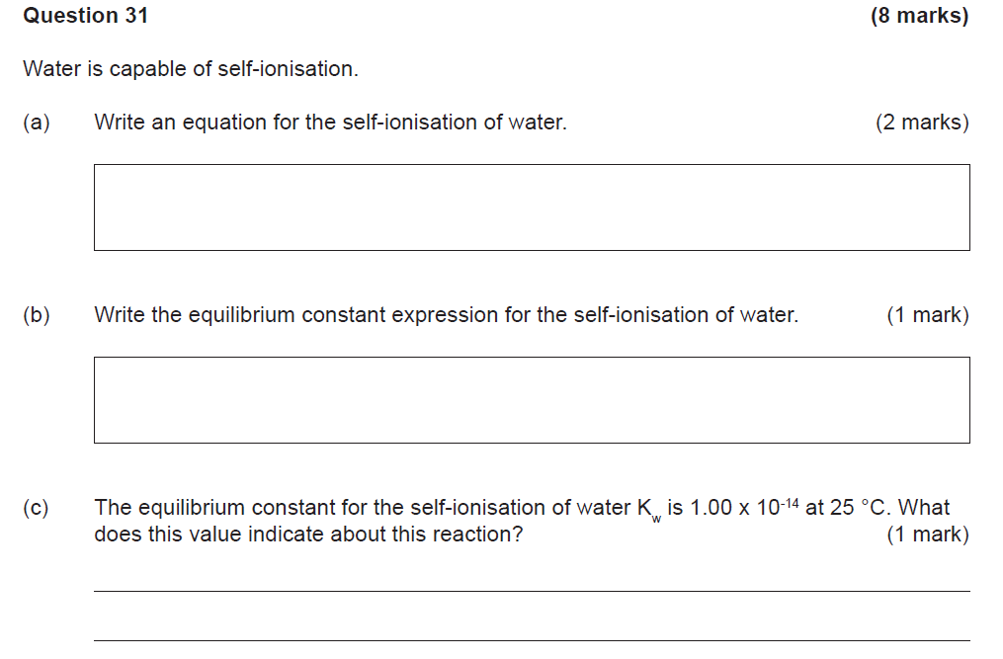

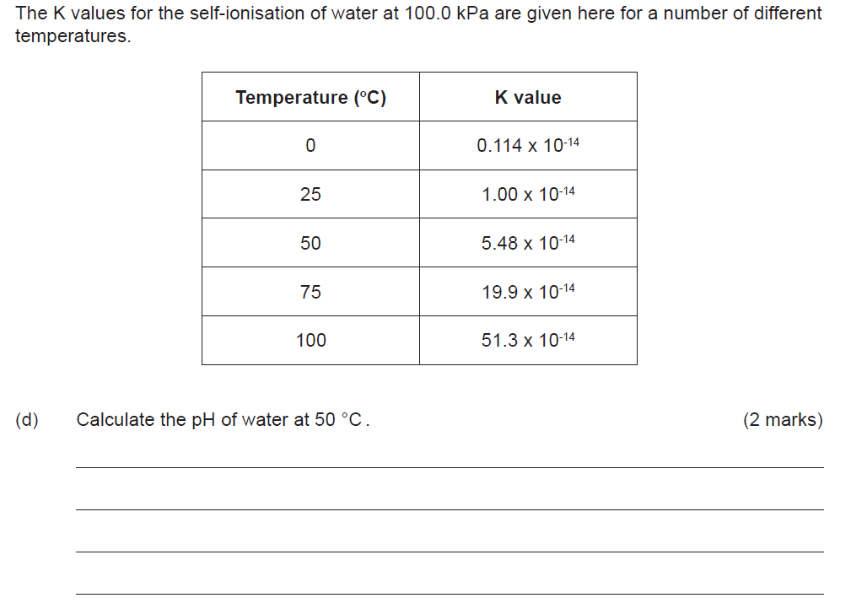

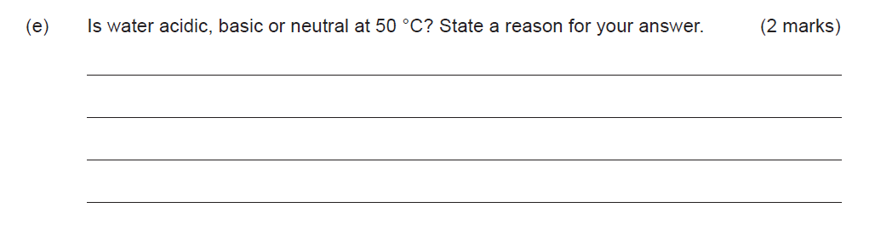

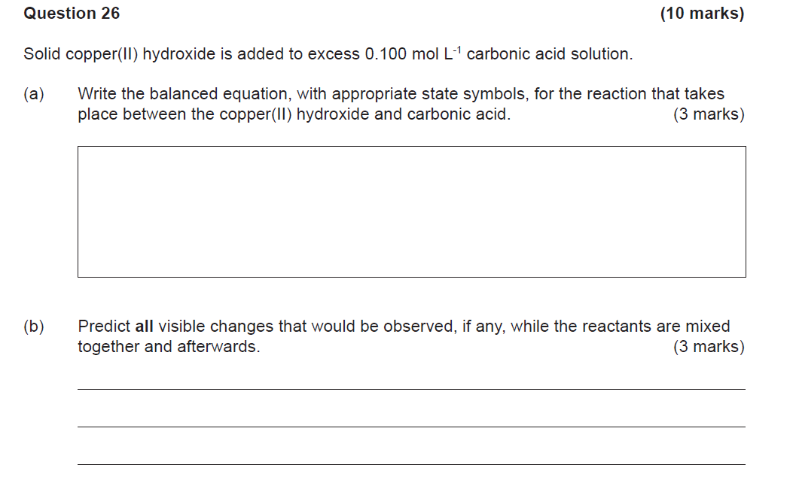

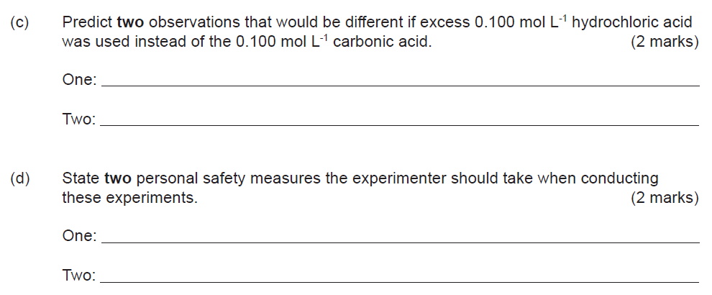

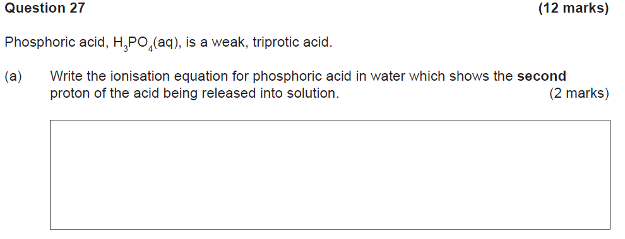

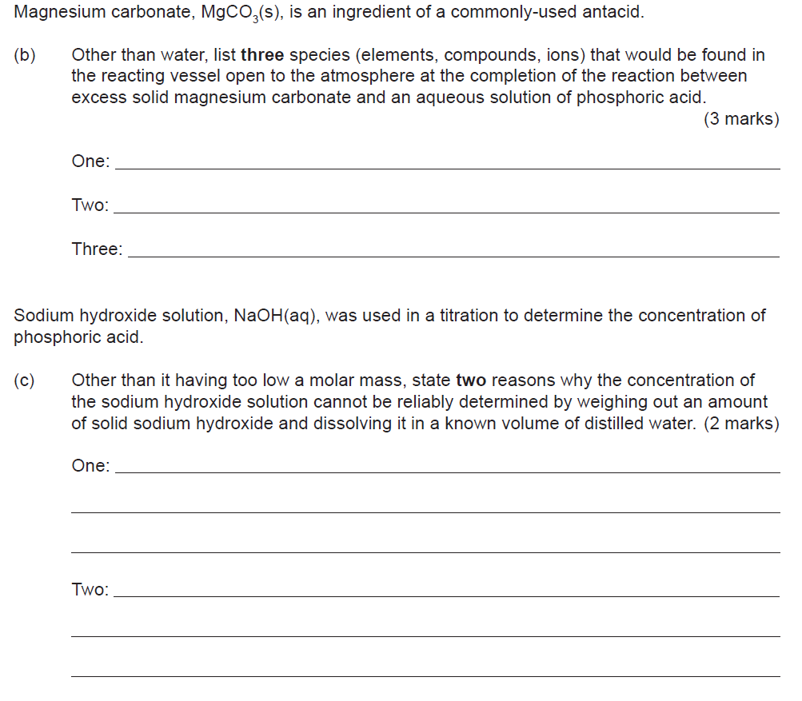

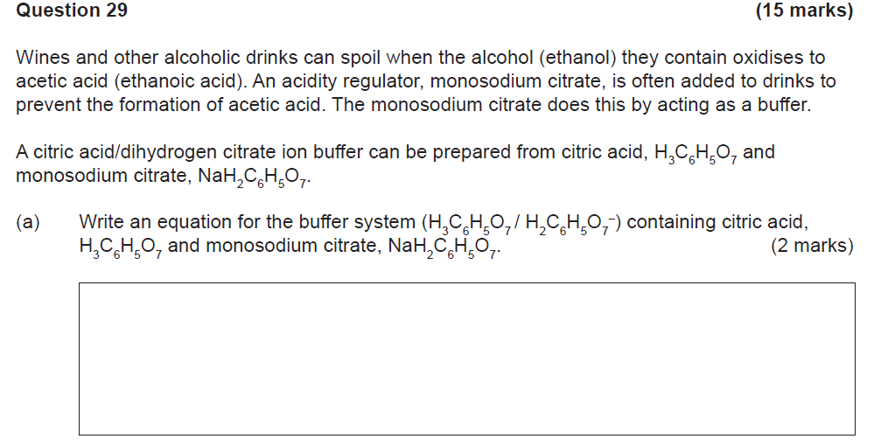

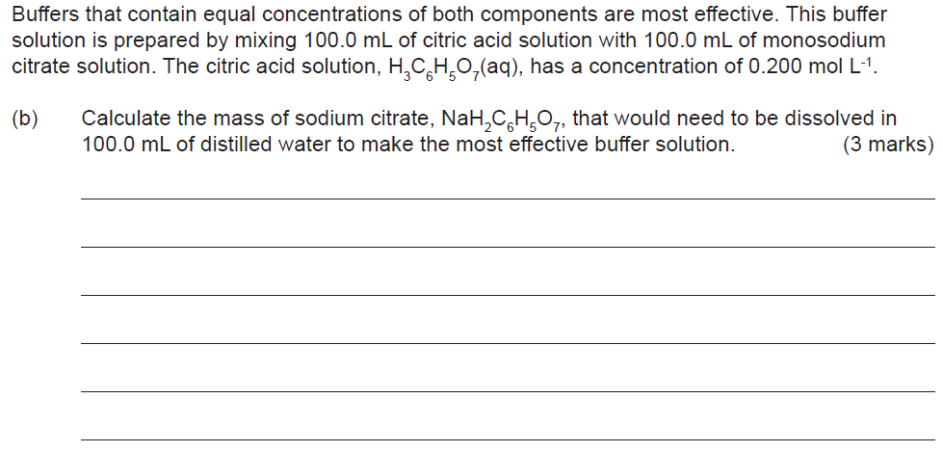

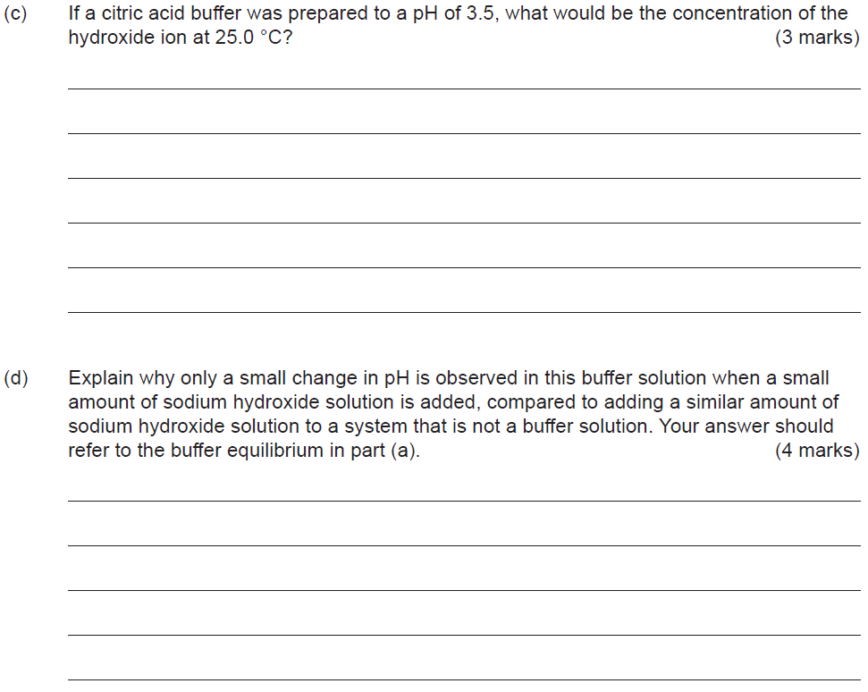

1. Consider the following data:

Barbituric acid HC4H3N2O3 Ka = 9.8 x 10-4 at 25oC

 If you were to put 2 .0 M of HC4H3N2O3 into pure distilled water what would:

1. The pH of the solution be to 2 significant figures [ **3 marks**, -1 for incorrect sig figs ]
2. Calculate the percentage ionisation of Barbituric acid, to 2 significant figures [ **2 marks**, -1 for incorrect sig figs ]